VBS Day Two — Flor in Peru

Outreach/Missions 25-minute Rotation Script with Resources

Tech resources to engage your audience:
Visit www.freewheelchairmission.org/vbs to download or order resources.
- Map and pictures of Peru
- Picture of Flor with Dr. Don
- Downloadable video of Flor receiving her wheelchair (long and short versions)
  - 3:52 version of Flor's Story
  - 0:27 version of Flor's Story
- Printable, two-sided Flor activity sheet

Script

Leader: Welcome to Day Two of our mission! My name is _____ and I’m excited to share more about our Mission together! Yesterday, we started our mission by hearing about Lotus Blossom, the young girl in India whose life was changed because she was lifted into a wheelchair with Dr. Don.
Leader: Today, I’d like to start by asking you a question. How did you get here today? How did you get from your home to VBS? Think about all the things that had to happen for you to get to VBS. Maybe you walked to the car, you had a parent drive you to church, and then you walked from the parking lot, walked on a sidewalk, and then sat in a chair. Now, imagine if you couldn’t walk and didn’t have a wheelchair or a car. How would you get to VBS? (Kids respond.)
Leader: Yes, that’s right! You would have to crawl or be carried, wouldn’t you? And as you grow, that would become harder and harder for your mom or dad to carry you. Do you think it would be easy for one of your parents to carry you on their back all the way here from home? No, it would be hard! But that’s what life is like for a lot of kids who live with disabilities. A disability is what it’s called when you cannot walk.
Tech: Show map and pictures of Peru

Leader: There is a beautiful country called Peru in South America. There are lots of mountains there and even part of the Amazon Rain Forest. A little girl named Flor lives there in the Andes mountains. She has three brothers and sisters. Her parents are farmers who grow potatoes and corn, they raise sheep and pigs, and make cheese with milk from their cow. Flor was born healthy, but when she was six months old, she developed a very high fever. Her parents couldn’t afford to take her to the doctor right away. Flor got even sicker, so they found a way to get her to the doctor. Flor had something very serious called meningitis, or a swelling of her brain and spinal cord.
Tech: Show picture of Flor and Dr. Don
Leader: Because of this injury to her brain and nervous system, Flor cannot walk or speak at the same level as her classmates in fourth grade. Her mother had been carrying her to school, but she wouldn’t be able to keep carrying her much longer because Flor was growing and would soon be taller and heavier than her mother. Without a way to get to school, Flor’s life would be so different. Then, a team from Free Wheelchair Mission and a church there in Peru heard about Flor. They prepared a new wheelchair to give her and drove for 3 hours on a winding mountain road to deliver it to her. She was so happy to sit in her very first wheelchair that she started singing and invited everyone else to sing along with her. This new wheelchair would change her life! Now, Flor could go to school, she could see her friends, and her mother wouldn’t have to try to carry her anymore.
Leader: Now that we know Flor’s story, we can see Flor receive her wheelchair by watching this video together!
Tech: Download and play video from Vimeo (3:52) - https://vimeo.com/226082034
Leader: Did you see that smile on Flor’s face when she saw her new wheelchair? She was so happy! And her mother was smiling and clapping her hands. Flor’s whole family was so excited and grateful, all because kids like YOU cared enough to give Flor a gift that changed her life!
Leader: Yesterday, on Day One of our Mission, we talked about ways we could reach our goal of ____ wheelchairs. That’s a big number and we’re going to need everyone to help us change all these lives with wheelchairs for people to get to school, to work, and to church, maybe even to VBS! We talked about all the ways we can reach our goal together and you guys came up with some really fantastic ideas. I’m sure some of you even went home and started a lemonade stand or a bake sale right away, didn’t you?
Leader: When I asked you who can change someone’s life, you guys had a great answer. Let’s see if you remember what that answer is. On the count of three, I’m going to ask you and I want you to shout out your answer. Ready? One, two three… Who do you think can change someone’s life with a wheelchair? (Kids – KIDS!)
Leader: I don’t think I heard everyone. Who can change lives? (Kids – louder, KIDS!)

Leader: That’s RIGHT! Kids can! Now, we’re going to get into our groups for our activity. Today, we’ll be making cards for people who receive wheelchairs! You can do anything you’d like, so get creative! You can draw a picture of your family, you can write something kind to the person who will receive a wheelchair, or you could even write a note AND draw a picture; it’s up to you!
Leader: But before we do that, let’s pray for God to continue be at work this week as we find ways to bless people with a wheelchair who need one. Pick a leader and ask if there’s someone in their group who would like to pray from the front.
Dismiss: I’ll see you tomorrow and I can’t wait to see how many wheelchairs we’re able to raise!
Optional: Create a slide with discussion questions for group time. (Examples: have you started a lemonade stand yet or thought about what you might do? How can we show God’s love to people who live in another country? Do you remember which country Flor lives in?)

Extra time options:
- Have more kids share their fundraising ideas with the whole group.
- Let kids color today’s activity sheet.
- Encourage kids to work on the memory verse for the week.

Email Prompts:

Edit the following email prompt to draw families into your VBS wheelchair goal. By sending the links to the same videos their child saw that day, families can join together to get creative along with their kids to jump in and get involved.

Day Two – Flor in Peru: Let’s lift lives together!
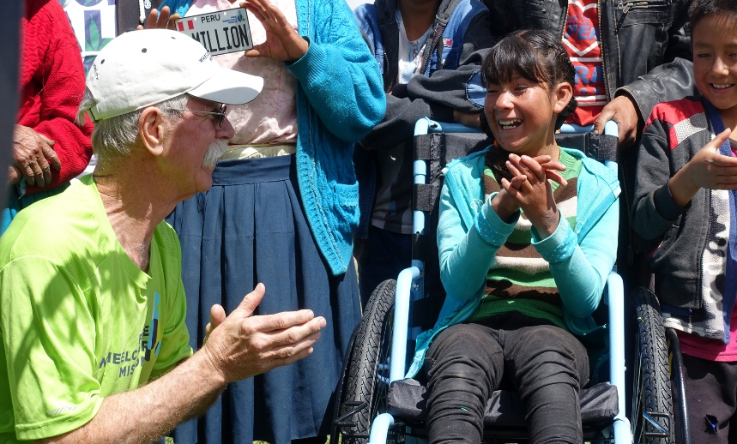
Today, kids were asked how they got to VBS this morning. They were asked to think about all that had to happen for them to arrive. Maybe they walked to the car, had a parent drive them, walked through the parking lot, then on a sidewalk, then they sat in a chair. But what if they couldn’t walk and didn’t have a car or a wheelchair? How would they get to VBS?
Some ideas were:
- Maybe they’d have to be carried around – but what if they’d grown too tall to be carried?
- Maybe they’d have to crawl – but what would happen to their hands, feet, and clothes?
- Maybe they’d have to stay home – but then they’d miss out on the friends and VBS fun!
Learning how much a life is impacted when mobility isn’t possible brings kids’ hearts of compassion into action. Loving others like Jesus means helping them when we can. And this week, we can!
Watch Flor, a 12-year-old girl from Peru who lives in the Andes mountains, receive her wheelchair. Her parents are farmers who work hard to provide for Flor and her brothers and sisters. When Flor developed a high fever as a baby, her parents discovered their daughter would not be able to walk or speak at the same level as her classmates. As Flor grew, it became a challenge for her mother to carry her to school and back.
When the team from Free Wheelchair Mission arrived with Flor’s new, durable wheelchair, she and her village burst into smiles and applause! Her life would be changed that day, through the generosity of supporters like your family! Now, Flor has mobility and no longer has to rely on her mother to carry her.
When someone is lifted into a wheelchair, they’re lifted into hope, a brighter future, and the message that they are loved by God. Now they can go to school, church, get a job, and visit with friends. Consider talking with your child about how you can continue to lift lives together this week into the gift of mobility. Maybe, with some creative thinking, your family can find ways to lift as many lives as possible.
Check out yesterday’s email for creative fundraising ideas to reach our goal of _____ wheelchairs!

