VBS Day Three — Truong in Vietnam

Outreach/Missions 25-minute Rotation Script with Resources

Tech resources to engage your audience:
Visit www.freewheelchairmission.org/vbs to download or order resources.
- Map and pictures from Vietnam, including:
  - Truong in his wheelchair
  - Truong being carried by his grandpa
  - Fields, a river, and a farmer in Vietnam
- Video of Truong being lifted into his new wheelchair (:27)
- Printable, two-sided Truong activity sheet

Script

Leader: I can’t believe it’s Day Three of our Mission already! Today, we’re heading all the way around the other side of the world. I hope you have a lot of energy this morning!
Leader: Tell me, did you all have breakfast this morning before coming to VBS? (Point to 2 different kids and ask if they ate breakfast.) Eating breakfast gives us energy for the day and keeps our tummies from grumbling, doesn’t it? Well, raise your hand if you made your own breakfast this morning. Now raise your hand if you needed help to make your breakfast or if someone else made it for you like your mom, dad, grandma, grandpa, or sibling. And now I’d like you to raise your hand if someone else washed the clothes your wearing, and because it’s Day Three of our Mission, I’m really hoping someone washed your VBS shirt you’ve been wearing!
Leader: The reason I’m asking you these questions is because it’s important to remember that kids need help every day for things like making sure you have food to eat and clothes to wear. In today’s story, we’re traveling all the way to Vietnam to meet a boy named Truong (pronounced “Trung”) who loves to go to school but who needs lots of help from his grandpa to get there.
Tech: Show map and pictures of Vietnam
Leader: Vietnam is a tropical country in Asia. It’s about the size of the states of Ohio, Kentucky, and Tennessee combined. Vietnam is near China and has about 96 million people who live there. To greet someone in Vietnamese, you would say, “Xin Chao (pronounced Sheen Chow).” Turn to your neighbor and say hello with a big “Xin Chao!” (Kids respond.) That sounds so great!
Tech: Show picture of Truong being carried by his grandpa
Leader: This is Truong. He is a nine-year old boy who lives in the Vietnamese countryside. He was born with cerebral palsy, a condition that affects his ability to control his muscles. He can’t walk, so he needed help to get anywhere. His parents couldn’t find jobs in their town, so they had to move away to the big city for work. They had to leave Truong with his grandpa, who takes very good care of Truong.
Leader: Every morning, Truong’s grandpa helps him get out of bed, brush his teeth, eat breakfast, and get ready for school. The family didn’t have enough money to buy a wheelchair for Truong, so his grandpa had to carry him to school and back every day. Remember on Day One of our Mission when we tried to move around without using our legs? We talked about how difficult it is to be carried by someone because kids grow, don’t they? Well, when Truong was younger and smaller, it was easier for his grandpa to carry him, but as Truong got older and heavier, it wasn’t as easy. His grandpa would have aches in his arms, shoulders, and back as he carried Truong a long way to school and back.
Tech: Show picture of a river in Vietnam
Leader: Not only that, but sometimes it rains very hard in Vietnam. It’s a tropical country where it rains a lot during monsoon season. A monsoon is a kind of storm with very heavy winds and rain. All of that would soak Truong and his grandpa, and would make the roads muddy, slippery, and dangerous for them both.
Leader: Truong’s grandpa would worry about slipping while he was carrying Troung in the rain. One day, Truong was given a brand-new wheelchair from Free Wheelchair Mission. This changed everything! Let’s watch this short video of the day Truong was lifted into his new wheelchair.
Tech: Show Video of Truong in his wheelchair (:27)
Leader: Did you see that big smile on Truong’s face?! Now, instead of carrying him, his grandpa could push him in his wheelchair! His grandpa’s shoulders, back, and arms wouldn’t be sore anymore, thanks to generous kids like you who cared enough to show God’s love by providing a wheelchair for Truong! When he saw his grandson sitting in his new wheelchair with a huge smile on his face, Truong’s grandpa said, “What a wonderful wheelchair! Now, we can visit friends and family, and Truong can get to school more easily!” This special gift of a wheelchair changed more than one life, didn’t it?!
Leader: Truong’s story is so great because he is a good student who learns fast. His favorite subject is math. His dream is to finish school, now that he has a wheelchair, and get a job so he can take care of his family. With his new wheelchair, Truong’s dream is closer to actually happening!
Leader: Remember, we have a big goal to changes lives this week together and help kids like Truong, wherever they live so they can get to school, church, or meet with friends, just like you do. We’re going to get into our groups and talk a little bit and pray, too. I can’t WAIT to see how many lives we change with only two more days to go!
Leader: Remind me again, who can change lives? (Kids – KIDS!) That’s right; KIDS! Let’s keep working towards our goal and encouraging each other to change lives! I’ll see you tomorrow!

Optional: Create a slide with discussion questions for group time.
Examples:
- Let’s pray for the people we’re raising wheelchairs for; for us to reach our goal, for them to know God’s love, for God to help us help them!
- How do you think giving a free wheelchair to someone who can’t afford it shows them God’s love?
- How did Jesus tell us we should treat other people?

Extra time options:
- Encourage kids to work on the memory verse for the week.
- Take time to review the Truong activity sheet.
- Have kids share how they’ve been fundraising with their group.

Email Prompts:

Edit the following email prompt to draw families into your VBS wheelchair goal. By sending the links to the same videos their child saw that day, families can join together to get creative along with their kids to jump in and get involved.

Day Three – Truong in Vietnam: Kids can make a big difference!
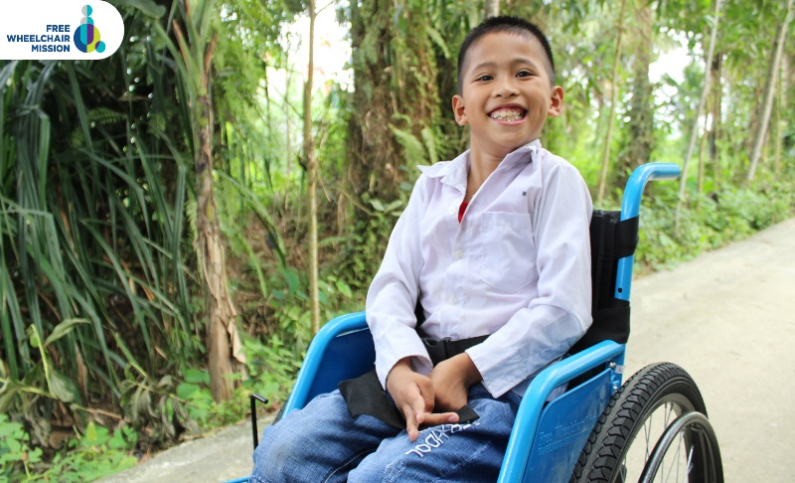
Truong is nine-year-old boy who lives in the Vietnamese countryside. He was born with cerebral palsy, a condition that affects his ability to control his muscles. Since he couldn’t walk, he needed help to get anywhere. Truong’s parents couldn’t find work in their town, so they had to make the difficult decision to leave their son with his grandpa while they worked in the big city. His grandpa took wonderful care of him, but it was difficult to carry him as he grew. Carrying Truong on his back to and from the long walk to school left his grandpa’s arms, shoulders, and back aching.
With the tropical rains during monsoon season, Truong’s grandpa would sometimes slip and fall on the journey to school. One day, Truong was given a brand-new wheelchair from Free Wheelchair Mission! This changed everything! Watch this short video of the day Truong was lifted into his new wheelchair.
Truong’s smile says it all. His life changed that day, but so did his grandpa’s! Now, his grandpa didn’t have to worry about his aching back, or monsoon’s making the walk to school dangerous for them both. Truong’s new wheelchair lifted a burden off this family, brightening their future and bringing God’s love into their lives. This happened only because of families like yours responding to the need and jumping in with ______ Church VBS to give the gift of mobility!
We’re more than halfway to our goal of _____ wheelchairs! Today, kids learned that because of their incredible efforts, we’ve raised enough for ______ wheelchairs, but we’re not done yet! Let’s keep going to lift as many lives as we can.

