VBS Day Five — Nakiwe in Eswatini

Outreach/Missions 25-minute Rotation Script with Resources

Tech resources to engage your audience:
Visit www.freewheelchairmission.org/vbs to download or order resources.
- Map and pictures of Eswatini
- Printable, two-sided Nakiwe activity sheet
- Optional: Free Wheelchair Mission’s 20th Anniversary Video (3:23)

Script

Leader: Welcome to Day Five of our mission around the world! What a week it’s been as we’ve learned about four special kids who live in four amazing places around the world. And you all have been working hard to get even more people in wheelchairs who otherwise wouldn’t be able to afford one.
Leader: Today, we’re visiting a country in Africa that is about the size of the state of New Jersey here in the US. This country is called Eswatini!
Tech: Show map and pictures of Eswatini
Leader: The country of Eswatini is landlocked, which means there is no ocean boarding this country. The landscapes range from cool mountain highlands to hot, grassy plains where you might see lions, elephants, and even hippos!
Leader: Most of Eswatini’s people live in the countryside, where they struggle to grow enough food to eat. The land suffers from frequent droughts, and when it does rain, the pours so hard and for so long that it often floods. There are only small plots of land to farm on, and livestock must compete for limited grazing lands for their food.
Leader: If you wanted to greet someone in Eswatini, you would say, “hello,” since most people in Eswatini can speak English.
Tech: Show picture of Nakiwe with her mother
Leader: Today, on our last day of our mission, I want to tell you about a 10-year-old girl named Nakiwe (pronounced Nah-kee-way) who searched everywhere for her favorite shirt. It was pink, her favorite color. She usually knew where to find it: in a basket of folded clothes that she kept near her bed, but this time, it wasn’t there.
Leader: Then she remembered that she had washed it a few days earlier and asked her mother to hang it out to dry. Nakiwe liked to help around the house, doing laundry, cooking, and feeding the chickens. Nakiwe wanted to do as much as possible by herself without anyone helping her. Nakiwe’s mother worked very hard out in the fields and must often leave her alone at home. Her mother worried about her a lot, though, because Nakiwe couldn’t walk.
Leader: This little girl was born with a condition that made her legs too weak to stand on. She could move her legs a little, but they weren’t strong enough to walk on. Her mother would have to carry her places, but when Nakiwe was home by herself, there was no one to carry her. She would have to crawl to get from her bed to the kitchen, and then from the kitchen to the bathroom. Remember when we talked on the first day of our mission about what it must feel like to have to crawl? We talked about how difficult it would be to have to get to school if we didn’t have legs that worked. Remember talking about what that would do to your clothes and how it might hurt your hands and knees, too?
Leader: Well, all this was about to change for 10-year-old Nakiwe. That’s why she was searching everywhere for her favorite pink shirt because on this day, she would get a new wheelchair from Free Wheelchair Mission. With this new wheelchair, Nakiwe’s mother can now push her to school, a three-mile trip each way, where her favorite subject is writing. Her mother said, “I don’t have to worry so much when I’m working in the fields because I know that my little girl will be safe in her wheelchair and can move around the house by herself. Thank you!”
Leader: We’ve been all around the world this week, learning about kids who needed someone to help lift them into a wheelchair. And because of all the hard work you’ve all done this week to help others, I can’t wait to see how many wheelchairs we’ve raised together! We’ll hear our grand total during today’s closing program. But first, we’re going to get in our groups and talk a little bit about all we’ve learned this week.
Optional: Show a slideshow of pictures that parents have sent in of kids in your VBS and all the ways they’ve fundraised this week to celebrate their efforts!
Optional: Create a slide with discussion questions for group time.
Examples:
- Let’s pray for the people who will be receiving wheelchairs because of all we did this week!
- In the Bible, the Lord says, “For I was hungry and you gave Me something to eat, I was thirsty and you gave Me something to drink, I was a stranger and you invited Me in, I needed clothes and you clothed Me, I was sick and you looked after Me, I was in prison and you came to visit me” (Matthew 25:35-36 NIV). When we help someone in need, it is as if we are serving God Himself. Can you think of something you can do to help someone else – maybe someone you’ve never met, halfway around the world? What can you do to bless someone else?
- We heard five stories of kids’ lives that were transformed by a wheelchair, but do you remember how it all started, back on Day One of our mission?
- Which of the five stories was your favorite and why?
- Take time to review the Nakiwe activity sheet.
Leader: I’m so proud of all you’ve done together to transform lives by giving a wheelchair to someone who needs one! I’ve heard so many stories of creative ways you all helped spread the word that people needed our help! Just think of all the lives that will be different now! The people who now be able to go to school, get a job, go to church, and be out in their communities, all because of the generosity you’ve shown this week! Let’s celebrate together with a HUGE round of applause!

Extra time options:
- Show the Free Wheelchair Mission video, “Together We Can Go Farther: 20 Years of Transforming Lives.” This video might be a great ending to your VBS week to celebrate all the students have achieved to lift people in wheelchairs!
- Encourage kids to work on the memory verse for the week.
- Have kids tell the group leader this week’s memory verse.
- Have kids share how they’ve been fundraising with their group.
Idea: Have your pastor join the Children’s Pastor/Ministry Director onstage for the big reveal of how many wheelchairs your VBS was able to raise and CELEBRATE!

Email Prompts:

Edit the following email prompt to draw families into your VBS wheelchair goal. By sending the links to the same videos their child saw that day, families can join together to get creative along with their kids to jump in and get involved.

Day Five – Nakiwe in Eswatini – What an amazing week we’ve had!
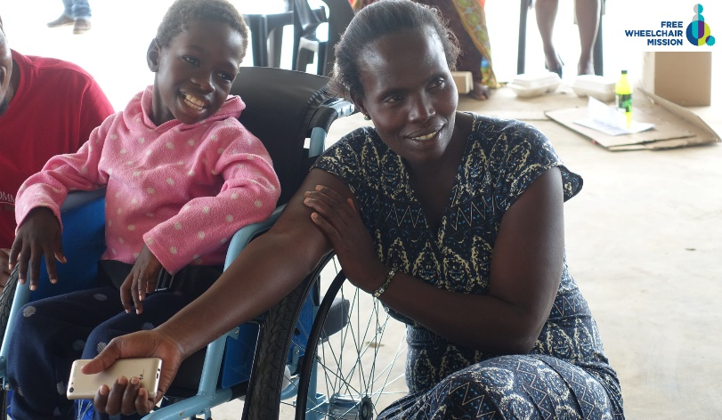
Your child has learned about five special kids who live in five amazing places around the world. And you all have been working hard to get even more people in wheelchairs who otherwise wouldn’t be able to afford one.
Today, we told the kids about the country of Eswatini in Africa. Most of Eswatini’s people live in the countryside, where they struggle to grow enough food to eat. The land suffers from frequent droughts, and when it does rain, the pours so hard and for so long that it often floods. There are only small plots of land to farm on, and livestock must compete for limited grazing lands for their food.
In Eswatini, there was a sweet 10-year-old girl named Nakiwe (pronounced Nah-kee-way), who searched everywhere for her favorite shirt. It was pink, her favorite color. She usually knew where to find it: in a basket of folded clothes that she kept near her bed, but this time, it wasn’t there. Then she remembered that she had washed it a few days earlier and asked her mother to hang it out to dry. Nakiwe liked to help around the house, doing laundry, cooking, and feeding the chickens. Nakiwe wanted to do as much as possible by herself without anyone helping her. Nakiwe’s mother worked very hard out in the fields and must often leave her alone at home. Her mother worried about her a lot, though, because Nakiwe couldn’t walk.
This little girl was born with a condition that made her legs too weak to stand on. She could move her legs a little, but they weren’t strong enough to walk on. Her mother would have to carry her places, but when Nakiwe was home by herself, there was no one to carry her. She would have to crawl to get from her bed to the kitchen, and then from the kitchen to the bathroom. Well, all this was about to change for 10-year-old Nakiwe. That’s why she was searching everywhere for her favorite pink shirt because on this day, she would get a new wheelchair from Free Wheelchair Mission. With this new wheelchair, Nakiwe’s mother can now push her to school, a three-mile trip each way, where her favorite subject is writing. Her mother said, “I don’t have to worry so much when I’m working in the fields because I know that my little girl will be safe in her wheelchair and can move around the house by herself. Thank you!”
We’ve been all around the world this week, learning about kids who needed someone to help lift them into a wheelchair. And because of all the hard work you’ve all done this week to help others, we are so happy to announce that together, we’ve raised enough for _______wheelchairs!
_______ VBS is so proud of all the creative efforts our families have been a part of as we changed lives together this week. Please join us in praying for these lives and for God’s love to be revealed to them.

