WHEELCHAIR SPECIFICATION GUIDE

We currently have three wheelchair models: GEN_1, GEN_2 and GEN_3.

GEN_1 is a single size, multipurpose wheelchair. It gives basic mobility to a broad range of users, but at the cost of adjustability to individuals. For users who do not need adjustments to the wheelchair to aid postural support and do not need to commute long distances, we recommend a GEN_1.

GEN_2 was designed with adjustability in mind, allowing customizations for each individual user’s personal needs. For users who do require more adjustment to the wheelchair and/or users that need to commute long distances, we recommend GEN_2.

GEN_3 is also an adjustable wheelchair, much like Gen_2, however the GEN_3 offers a folding option. For users who require more adjustments and also live in urban areas and travel frequently using public transportation we recommend GEN_3.

Ultimately, most of the decision making in regards to which chairs are provided is determined by our distribution partners. GEN_2 and GEN_3 are much more involved wheelchairs than GEN_1 by virtue of their adjustability. We have developed training and fitting procedures so this will not slow our most active distribution partners, but we anticipate that some of our partners, particularly our smaller ones, may choose to stay with the GEN_1 wheelchair because of demand

GEN_1 Wheelchair Overview

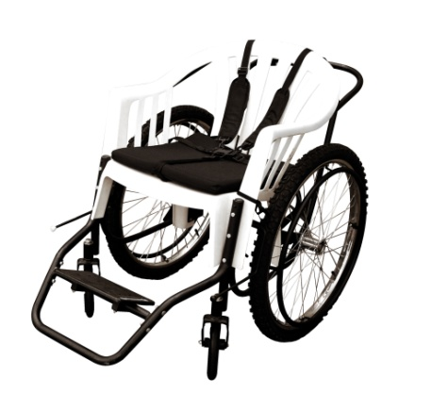

The GEN_1 wheelchair is an appropriate device for a large range of users. It provides mobility while remaining cost-effective and safe for its users.

GEN_1 uses a resin chair designed to be a simple, durable seat for its users. We generally recommend the GEN_1 design for adult users.

GEN_1 Specific Traits:

- Comes in one size.
- Seat and backrest is a single plastic chair. The resin includes UV-resistant additives to diminish damage from sunlight. It is designed to fit medium-sized adults (≤90kg/198lbs).
- Uses 60.9cm x 5.4cm (24" x 2.125") rear wheels, with 36-spoke chrome-steel rims and 1.2cm (.47”) diameter axles. Wheels include 1.6cm (.63”) diameter black painted steel push-rims with four attachment points.
- Front wheels are large, rubber castors (diameter: 20cm/7.87”, width: 4cm/1.6”) for increased wheelbase and stability.
- Wheelchairs arrive unassembled: assembly takes about 15 minutes. ALL required tools are provided with each container. There are 50 toolkits in each container which averages to one toolkit/11 chairs.
- Footrest can be adjusted to four different leg lengths with a range of 31cm/12.2”. The footrest provides a stationary, single footplate for both feet. The angle of the footrest can be adjusted to suit each individual user's needs.
- An optional harness helps provide secure seating for smaller users and users requiring additional postural support.
- Color: The chair is white, frame and wheels are black.

GEN_2 Wheelchair Overview:

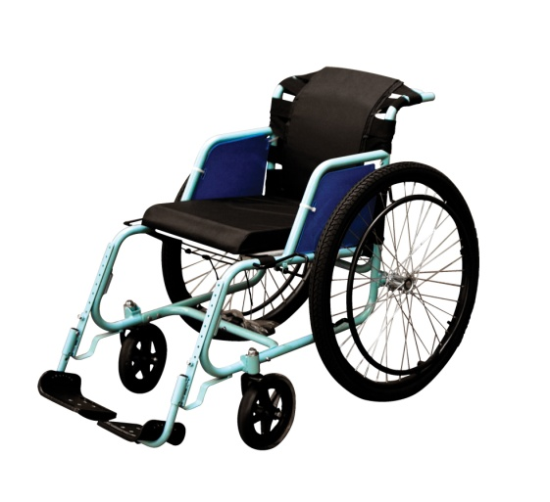

GEN_2 is the first evolution of our GEN_1 concept. Our goal was to add adjustability without adding significant cost. We designed GEN_2 to be a more customizable variant of the GEN_1 design. It allows adjustments to its width, seat length, backrest height and is capable of a large range of footrest positions. We can configure it to give optimum postural support for users with special needs from small children to large adults. The rear wheels have been positioned to make movement more efficient thus facilitating travel over long distances.

GEN_2 Specific Traits:

- Comes in four seat widths: small, medium, large, extra-large
- All three sizes come in kits contained in a brown, five-ply cardboard box with black printed graphics. Packaging is not waterproof.
- Wheelchairs arrive unassembled: assembly takes about 20 minutes. ALL required tools are provided with each container. There are 50 toolkits in each container which averages to one toolkit/11 chairs.
- Product is ISO: 7176 – 1,3,5,7,8,15,16 tested and passed (including fire retardant foam and fabric). US FDA cleared the GEN_2 for sale in the USA in 2012.
- GEN_2 is designed to provide a custom fit to a wide range of users.
- Color: Free Wheelchair Mission light blue.

GEN_3 Wheelchair Overview
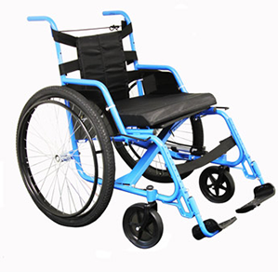

GEN_3 is the latest evolution of our GEN_2 concept. Our goal was to add a folding component to our wheelchair, as this was this largest request we received from the field upon seeking feedback from our first two iterations of wheelchairs. We designed GEN_3 to be just as adjustable as the Gen_2, but allow for wheelchair users and family members to fold for easier storage and transport. It allows adjustments to its width, seat length, backrest height and is capable of a large range of footrest positions. We can configure it to give optimum postural support for users with special needs from small children to large adults. The rear wheels have been positioned to make movement more efficient thus facilitating travel over long distances.

Gen_3 Specific Traits

- Comes in four seat widths: small, medium, large, and extra-large.
- All four sizes come in kits contained in a brown, five-ply cardboard box with black printed graphics. Packaging is not waterproof. Outside dimensions – 690x690x330mm (27.2” x 27.2” x 13”). There are 420 wheelchair kits in a 40 foot high cube container.
- Wheelchairs arrive unassembled: assembly takes about 20 minutes. ALL required tools are provided with each container. There are 50 toolkits in each container which averages to one toolkit/11 chairs.
- Product is ISO: 7176 – 1,3,5,7,8,15,16 tested and passed (including fire retardant foam and fabric). US FDA cleared the GEN_2 for sale in the USA in 2014.
- GEN_3 is designed to provide a custom fit to a wide range of users while offering a folding option for easy storage and transport.
- Color: Free Wheelchair Mission dark blue.
- Net weight of wheelchair is 19.1kg/42lb (small), 19.9kg/43.8lb (medium), 20.9kg/46lb (large), and 22.2kg/49lb (extra-large).

GEN_1, GEN_2 and GEN_3 Shared Characteristics:

- All are semi-urban, all-purpose wheelchairs allowing both self and attendant propulsion. The wheelchairs are designed for use over rough ground and in conditions normally found in semi-urban or rural areas. However, the wheelchairs can be easily utilized in an urban setting. Users may require assistance over extremely rough ground, high curbs or steep inclines even with the wheelchairs.
- Wheelchair parts are easy to repair/replace if need be, and both chairs use common wheel and bearing sizes.
- Wheelchairs come in kits that include all required parts and tools for assembly as well as a basic maintenance kit (includes air pump and patch kit).
- Supplied with each wheelchair is a comfort cushion with a water-resistant, fire-resistant nylon cover. The cushion is for users who do not have a high risk of pressure ulcer development or significant postural deformity. These groups may be defined as follows:
  - Short-term users: Requiring a wheelchair for less than six months OR who use a wheelchair less than four times per week OR who use a wheelchair for less than 2-3 hours at a time.
  - Long-term users: With sensation in their buttocks AND have the ability to shift their weight off their buttocks OR users who can sit up well on their own in the wheelchair AND are without significant postural deformities.
- Wheelchairs have built-in armrest supports to facilitate pressure relief lifts, transfers and sitting in a rested position. The armrests have sides to protect both the user and the sides of the cushion from mud during use.
- Steel over-lock brakes can be adjusted with minor hand bending.
- Products are designed to provide at least three years of service under general use and provided the wheelchair is appropriately maintained. Along with a basic maintenance kit, each user receives contact information should service, maintenance or information be required.

GEN_2 and GEN_3 Shared Characteristics

- Both use 66cm x 5.4cm rear wheels, with 36 spoke chrome steel rims and black painted steel push rims, attached in four places.
- Tires are pneumatic with medium tread.
- Front wheels are large, rubber castors to increase wheelbase and stability.
- Seat base can be adjusted to three different depths: 29cm/11.4”; 36cm/14.2”; and 43cm/16.9”. It includes a comfort cushion.
- Backrest is set at 90˚ to the seat. The backrest can be set in four height positions (30cm/11.8”; 36cm/14.2”; 42cm/16.5”; and 48cm/18.9”). It is composed of EVA foam padding inside a water-resistant, fire-retardant nylon cover.
- Push handles provided—height is dependent on height of backrest.
- Footrests can be adjusted to 10 different positions with a range of 40cm/15.5” and provide independent height adjustment for each foot. They can swing away 180˚ to aid transfers. A calf strap is supplied with the wheelchair
- Optional seat belts provide secure seating for users who require additional postural support.
- Color: Free Wheelchair Mission light- and dark-blue.

